Government of the People’s Republic of Bangladesh
Ministry of Local Government, Rural Development & Cooperatives
Local Government Division
Urban Primary Health Care Services Delivery Project
Project Management Unit

Consulting Services for:
Urban Primary Health Care Services Delivery Project
Service Package No. S-4.1 (Operations Research)

Fifth Quarter Progress Report

Submitted by:

International Centre for Diarrhoeal Disease Research, Bangladesh (icddr,b)

November 30, 2016

Table of Contents
1. Introduction 4
2. Goal of the Assignment 4
3. Project Activities 5
3.1 Data Collection - HDSS Second Round 5
3.2 Repeated Visits to Absentee Households - HDSS Second Round 6
3.3 Data Cleaning/Field Verification - HDSS Second Round 6
3.4 Report Writing: Baseline Population and Socioeconomic Census 6
3.5 Data Collection - HDSS Third Round 6
3.6 Field Workers’ Training and Data Collection - Health Expenditure, Payment, and Financial Coping Mechanisms Survey 6
3.7 Data Cleaning/Field Verification - Health Expenditure, Payment, and Financial Coping Mechanisms Survey 7
3.8 Report Writing- Health Expenditure, Payment, and Financial Coping Mechanisms Survey 7
3.9 Pretesting/Finalization of Questionnaire- Migration and Mobility Determinants on Health Survey 7
3.10 Computer Program - Migration and Mobility Determinants on Health Survey 7
3.11 Field Workers’ Training and Data Collection- Migration and Mobility Determinants on Health Survey 8
3.12 Data Cleaning/Field Verification - Migration and Mobility Determinants on Health Survey 8
3.13 Report Writing - Migration and Mobility Determinants on Health Survey 8
3.14 Pretesting/Finalization of Questionnaire - Health Seeking Behaviour: Maternal, Neonatal and Child Health Including Family Planning, Adolescents’ Reproductive Health, Violence against Women Survey 8
3.15 Computer Program- Health Seeking Behaviour: Maternal, Neonatal and Child Health including Family Planning, Adolescents’ Reproductive Health, Violence against Women Survey 9
3.16 Field Workers’ Training and Data Collection- Health Seeking Behaviour: Maternal, Neonatal and Child Health Including Family Planning, Adolescents’ Reproductive Health, Violence against Women Survey 9
4. Comparative Statement on Activities Planned and Accomplished 9
5. Conclusion 9

Figures
Figure 1: Location of Slums: Dhaka North, Dhaka South and Gazipur City Corporations 11
Figure 2: Time Line of Activities/Events (Jul 8, 2016 to Oct 7, 2016) 12

1. Introduction

This report has been prepared in fulfillment of the requirements mentioned in the contract agreement of the project “Primary Health Care Services Delivery Project (Urban Health and Demographic Surveillance System); Service Package No. S-4.1 (Operations Research)”. According to the Terms of Reference, “Quarterly Progress Report should be submitted within 21 days after the end of each quarter”.

For understanding the population, health and socioeconomic problems prevailing in the slums, currently, available data are necessary but not sufficient to deal with these problems. So, there is a need to establish a data collection system (Health and Demographic Surveillance System) for capturing data from the slum population of Bangladesh, which will enable monitoring the health, demographic and socioeconomic indicators, and facilitating the evaluation of intervention programs.

icddr,b has been the pioneer institute to develop and maintain Health and Demographic Surveillance Systems (HDSS). Currently, icddr,b has three rural HDSSs and two urban disease surveillances in place. Dedicated to saving lives through research and treatment, icddr,b addresses some of the most critical health concerns facing by the world today, ranging from neonatal survival to HIV/AIDS.

2. Goal of the Assignment

The goal of the project is to set up a Health and Demographic Surveillance System in the selected slums of Dhaka and Gazipur City (See Map, Figure 1: Location of Slums). More specifically, the project is aimed to establish a data collection system to assess the levels of fertility, mortality, migration, marriage and divorce, family planning, violence against women, morbidity, sickness care, health expenditure, migration and mobility determinants of health, and knowledge and practice of non-communicable diseases.

The outcomes are: population profile with measures of fertility, mortality, migration, marriage and divorce along with four publishable manuscripts based on the survey data [health expenditure, migration and mobility determinants of health, health seeking behavior (MNCH), family planning, violence against women, and knowledge and practice of non-communicable diseases].

The milestones achieved during the fifth quarter of the study (Jul 8, 2016 to Oct 7, 2016) were: a) Data collection, repeated visits to absentee households and data cleaning/field verification- HDSS second round; b) Report writing: Baseline population and socioeconomic census; c) Data collection and data cleaning/field verification - Health expenditure, payment and financial coping mechanisms survey; d) Pretesting/finalization of questionnaire and computer program - Migration and mobility determinants on health survey; e) Data collection and data cleaning/field verification - Migration and mobility determinants on health survey; f) Pretesting/finalization of questionnaire - Health seeking behaviour: maternal, neonatal and child health including family planning, adolescent reproductive health, violence against women survey; and g) Computer program - Health seeking behaviour: maternal, neonatal and child health including family planning, adolescents’ reproductive health, violence against women survey.

3. Project Activities

The following activities were carried out by icddr,b during the fifth quarter of the study (Jul 8, 2016 to Oct 7, 2016) (See Activities/Events, Figure 2: Time Line of Activities/Events).

The activities were:

- Data collection - HDSS second round (Apr 24, 2016 to Jul 23, 2016)
- Repeated visits to absentee households - HDSS second round (Apr 24, 2016 to Jul 31, 2016)
- Data cleaning/field verification - HDSS second round (Apr 24, 2016 to Jul 31, 2016)
- Report writing: Baseline population and socioeconomic census - Incorporating comments by the Technical Review Committee members (May 22, 2016 to Jul 31, 2016)
- Data collection - HDSS third round (started on Jul 24, 2016, ongoing)
- Field workers’ training and data collection - Health expenditure, payment, and financial coping mechanisms survey (Jun 1, 2016 to Jul 31, 2016)
- Data cleaning/field verification - Health expenditure, payment, and financial coping mechanisms survey (Jun 15, 2016 to Jul 31, 2016)
- Report writing - Health expenditure, payment, and financial coping mechanisms survey (started on Aug 1, 2016, ongoing)
- Pretesting/finalization of questionnaire - Migration and mobility determinants on health survey (Jul 1, 2016 to Jul 14, 2016)
- Computer program- Migration and mobility determinants on health survey (Jul 15, 2016 to Jul 31, 2016)
- Field workers’ training and data collection - Migration and mobility determinants on health survey (Aug 1, 2016 to Sep 30, 2016)
- Data cleaning/field verification - Migration and mobility determinants on health survey (Aug 15, 2016 to Sep 30, 2016)
- Report writing - Migration and mobility determinants on health survey (started on Oct 7, 2016, ongoing)
- Pretesting/finalization of questionnaire - Health seeking behaviour: maternal, neonatal and child health including family planning, adolescents’ reproductive health, violence against women survey (Sep 1, 2016 to Sep 14, 2016)
- Computer program - Health seeking behaviour: maternal, neonatal and child health including family planning, adolescents’ reproductive health, violence against women survey (Sep 15, 2016 to Sep 30, 2016)
- Field workers’ training and data collection - Health seeking behaviour: maternal, neonatal and child health including family planning, adolescents’ reproductive health, violence against women (started on Oct 1, 2016, ongoing)

3.1 Data Collection - HDSS Second Round

As mentioned in the earlier reports, Field Research Coordinator with support from three Field Research Assistants prepared monthly work plan for 15 female Field Workers for visiting 30,000 households to collect HDSS data; one additional female Field Worker was kept for leave coverage. Each Field Worker was assigned to visit about 40 households every day to complete her assigned area within three months (Aug 24, 2016 to Jul 23, 2016).

The Field Workers also carried printouts of household listing in addition to data in the Tab to find the baris. Once a bari was identified, the Field Workers entered the slum name, area name and bari number into the Tab to verify the record with the printouts.

Every day, a Field Worker visited her assigned households and performed roll call with the help of database loaded earlier in the portable devices (Tab). This was to detect events, if any event had occurred for any household member since her last visit. In case of any event, the interviewers entered the identification number into the portable devices and selected basic information from the database.

Repeated Visits to Absentee Households - HDSS Second Round

During the HDSS data collection, some households did not have eligible respondents to provide the information. These households were visited again in the next day (morning or lunch time) and were interviewed, if eligible respondent was found. The remaining absentee households were visited again after the completion of the second round HDSS data collection (Apr 24, 2016 to Jul 31, 2016).

3.3 Data Cleaning/Field Verification - HDSS Second Round

Although some logics had been incorporated into the data collection program, some errors were detected in the data during preparation of frequency tables. As mentioned earlier, every type of logic was not introduced in the data collection program as it would slow down the data collection process. So, there were some errors in the data file, and the data cleaning continued for longer than it was originally expected (Apr 24, 2016 to Jul 31, 2016).

3.4 Report Writing: Baseline Population and Socioeconomic Census

The baseline population and socioeconomic census report was divided into seven chapters including the introduction. The second chapter discussed the methods and procedures, while the main reporting started from chapter three and continued to seven. Chapter seven dealt with the challenges to establish HDSS in the slum areas (Mar 22, 2016 to Jul 31, 2016).

3.5 Data Collection - HDSS Third Round

For HDSS third round, the data collection procedure was similar to those of previous rounds. The Field Research Coordinator, with support from three Field Research Assistants, prepared monthly work plan for 15 female Field Workers for visiting 30,000 households; one additional female Field Worker was kept for leave coverage. Each Field Worker was assigned to visit about 40 households every day to complete her assigned area within three months (started on Jul 24, 2016, ongoing).

3.6 Field Workers’ Training and Data Collection - Health Expenditure, Payment, and Financial Coping Mechanisms Survey

At first, three Field Research Assistants were trained on questionnaires by the PI (Dr. Shehrin Shaila Mahmood) and the Field Research Coordinator. Subsequently, 16 female Field Workers were trained by the Field Research Coordinator and Field Research Assistants. During training, female Field Workers were trained on data collection instruments, data collection devices and interviewing techniques. The training on data collection devices (use of Tab) was organized by the Computer Programmer. Duration of the training was for seven days: five days in office (training on questionnaires, mock interview and use of Tab), and two days for field practice (Aug 1, 2016 to Sep 30, 2016).

The Field Research Coordinator, in consultation with three Field Research Assistants, prepared work plans for the “Health expenditure, payment, and financial coping mechanisms” survey. Each Field Worker (15 female Field Workers were enlisted/assigned for visiting 1000 households for the Health Expenditure survey; one additional female Field Worker was kept for leave coverage) was assigned to cover/visit about 70 households (2-3 households per day) and to complete her assigned households within six weeks in addition to HDSS data collection (Jun 1, 2016 to Jul 31, 2016).

3.7 Data Cleaning/Field Verification - Health Expenditure, Payment, and Financial Coping Mechanisms Survey

Although some logics had been incorporated into the data collection program, some errors were also detected in the data during preparation of frequency tables (using Stata/SPSS). However, it was not recommended to introduce every type of logic to the data collection program as it would slow down the data collection process. So, some errors were detected through logical checks program, and the data were cleaned using existing records/field visits (Jun 15, 2016 to Jul 31, 2016).

3.8 Report Writing- Health Expenditure, Payment, and Financial Coping Mechanisms Survey

The health expenditure, payment, and financial coping mechanisms survey report was divided into three chapters including the introduction. The second chapter discussed the methods and procedures, while the third chapter was on report findings: demographic characteristics of study population, proportion of people ill and their health care seeking behavior, last 14 days illness, hospitalization, chronic illness, and cost of health care (started on Aug 1, 2016, ongoing).

3.9 Pretesting/Finalization of Questionnaire- Migration and Mobility Determinants on Health Survey

Pretesting the migration and mobility determinants of health questionnaire was initially done by two female Field Workers under the guidance of PI (Dr. Abdur Razzaque) and the Field Research Coordinator. Feedback received from the field test was reviewed by the PI and Co-PIs, and useful suggestions were incorporated in finalizing the questionnaires (Jul 1, 2016 to Jul 14, 2016). However, these questionnaires were approved earlier by the Research Review Committee as well as the Ethical Review Committee of icddr,b.

3.10 Computer Program - Migration and Mobility Determinants on Health Survey

The data were collected using portable electronic devices (Tab), and the data collection program was developed accordingly. Some consistency checks were incorporated to the data collection program (Jul 15, 2016 to Jul 31, 2016).

3.11 Field Workers’ Training and Data Collection- Migration and Mobility Determinants on Health Survey

At first, three Field Research Assistants were trained on questionnaires by the PI (Dr. Abdur Razzaque) and the Field Research Coordinator. Subsequently, 16 female Field Workers were trained by the Field Research Coordinator and Field Research Assistants. During training, female Field Workers were trained on data collection instruments, data collection devices and interviewing techniques. The training on data collection devices (use of Tab) was organized by the Computer Programmer. Duration of the training was for seven days: five days in office (training on questionnaires, mock interview and use of Tab), and two days for field practice (May 22, 2016 to May 31, 2016).

The Field Research Coordinator, in consultation with three Field Research Assistants, prepared work plans for the ”health expenditure, payment, and financial coping mechanisms” survey. Each Field Worker (15 female Field Workers were enlisted for visiting 1000 households for the Health Expenditure survey; one additional female Field Worker was kept for leave coverage) was assigned to cover about 70 households (2-3 households per day) and to complete her assigned households within six weeks in addition to HDSS data collection (Aug 1, 2016 to Sep 30, 2016).

3.12 Data Cleaning/Field Verification - Migration and Mobility Determinants on Health Survey

Although some logics had been incorporated into the data collection program, some errors were also detected in the data during preparation of frequency tables (using statistical package). However, it was not recommended to introduce every type of logic to the data collection program as it would slow down the data collection process. So, some errors were detected through logical checks program, and the data were cleaned using existing records/field visits (Aug 15, 2016 to Sep 30, 2016).

3.13 Report Writing - Migration and Mobility Determinants on Health Survey

After cleaning the first and second round data, analyses were performed using the statistical package (Stata/SPSS). The report was divided into four chapters including the introduction. The second chapter dealt with methods and materials, the third chapter discussed results, and the fourth chapter was on discussion of findings (started on Oct 7, ongoing).

3.14 Pretesting/Finalization of Questionnaire - Health Seeking Behaviour: Maternal, Neonatal and Child Health Including Family Planning, Adolescents’ Reproductive Health, Violence against Women Survey

Pretesting the “hearth seeking behaviour: maternal, neonatal and child health including family planning, adolescents’ reproductive health, violence against women” survey questionnaire was initially done by two female Field Workers under the guidance of the PI (Dr. Mohammad Iqbal) and the Field Research Coordinator. Feedback received from the field test was reviewed by the PI and Co-PIs, and useful suggestions were incorporated in finalizing the questionnaires (Sep 1, 2016 to Sep 14, 2016). However, these questionnaires were approved earlier by the Research Review Committee as well as the Ethical Review Committee of icddr,b.

3.15 Computer Program- Health Seeking Behaviour: Maternal, Neonatal and Child Health including Family Planning, Adolescents’ Reproductive Health, Violence against Women Survey

The data were collected using portable electronic devices (Tab) and the data collection program was developed accordingly. Some consistency checks were incorporated to the data collection program (Sep 15, 2016 to Sep 30, 2016).

3.16 Field Workers’ Training and Data Collection- Health Seeking Behaviour: Maternal, Neonatal and Child Health Including Family Planning, Adolescents’ Reproductive Health, Violence against Women Survey

At first, three Field Research Assistants were trained on questionnaires by the PI (Dr. Mohammad Iqbal) and the Field Research Coordinator. Subsequently, 16 female Field Workers were trained by the Field Research Coordinator and Field Research Assistants. During training, female Field Workers were trained on data collection instruments, data collection devices and interviewing techniques. The training on data collection devices (use of Tab) was organized by the Computer Programmer. Duration of the training was for seven days: five days in office (training on questionnaires, mock interview and use of Tab) and two days for field practice.

The Field Research Coordinator, in consultation with three Field Research Assistants, prepared work plans for the “Health Expenditure, Payment, and Financial Coping Mechanisms” survey. Each Field Worker (15 female Field Workers were enlisted for visiting 1000 households for the Health Expenditure survey; one additional female Field Worker was kept for leave coverage) was assigned to cover about 70 households (2-3 households per day) to complete her assigned households in six weeks in addition to their HDSS data collection (started on Oct 1, 2016, ongoing).

4. Comparative Statement on Activities Planned and Accomplished

During the fifth quarter of the study (Jul 8, 2016 to Oct 7, 2016), it was planned to complete the second round HDSS data collection, write report with first and second rounds HDSS data, complete data collection of the “health expenditure, payment, and financial coping mechanisms” survey, start data collection of the “migration and mobility determinants on health” survey, and start data collection of the “hearth seeking behaviour: maternal, neonatal and child health including family planning, adolescents’ reproductive health, violence against women” survey. In fact, the “health expenditure, payment, and financial coping mechanisms” survey took a longer time (two weeks) than it was originally planned, which caused delay in starting the survey on “migration and mobility determinants on health”.

5. Conclusion

During the fifth quarter of the study, it was planned to complete the second round HDSS data collection on Jul 23, 2016, start the third round HDSS data collection on Jul 24, 2016, and prepare report of the “health expenditure, payment, and financial coping mechanisms” survey; these were completed in time. The survey on “health expenditure, payment, and financial coping mechanisms” was supposed to be completed by Jul 15, 2016, but it took two weeks more than it was originally planned. To overcome this two weeks’ delay, we worked for extra hours for the “migration and mobility determinants on health” survey to complete the work in time.

Figure 1: Location of Slums: Dhaka North, Dhaka South and Gazipur

City Corporations

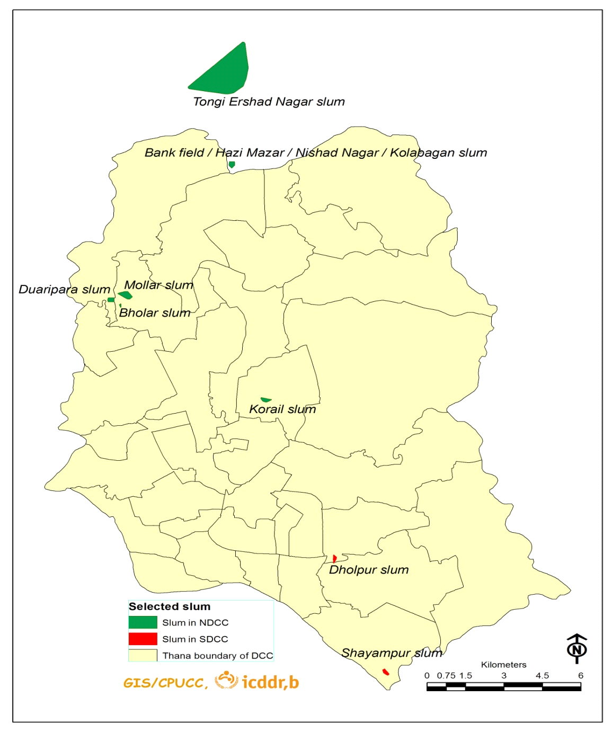

Figure 2: Time Line of Activities/Events (Jul 8, 2016 to Oct 7, 2016)

Activities/Events | July |  |  | August |  |  |  | September |  |  |  |  | Oct
 | 8-15 | 16-23 | 24-31 | 1-7 | 8-14 | 15-21 | 22-31 | 1-7 | 8-14 | 15-21 | 22-28 | 29-30 | 1-7
- Data collection - HDSS second round
- Repeated visits to absentee households- HDSS second round
- Data cleaning/field verification- HDSS second round
- Report writing: Baseline population and socioeconomic census
- Data collection- HDSS third round |  |  |  |  |  |  |  |  |  |  |  |  | +
- Field worker’s training and data collection- Health expenditure survey
- Data cleaning/field verification- Health expenditure survey
- Report writing- Health expenditure survey |  |  |  |  |  |  |  |  |  |  |  |  | +
- Pretesting/finalization of migration and health survey
- Computer program- Migration and health survey
- Field worker’s training/data collection- Migration and health survey
- Data cleaning/field verification- Migration and health survey
- Report writing- Migration and health survey |  |  |  |  |  |  |  |  |  |  |  |  | +
- Pretesting/final-of-questionnaire- Health seeking behaviour (MNCH)
- Computer program- Health seeking behaviour (MNCH)
- Field worker’s training/data collection- Health seeking behaviour (MNCH) |  |  |  |  |  |  |  |  |  |  |  |  | +
Note: ⁺Ongoing.

